**Installing and configuring the ODK Collect Android app to collect data and send to a an ODK aggregate server**

Description: This document is a simple guide on how to do offline or online survey data collection via a mobile app and synchronize the data with the Open Data Kit data collection server also known as the ODK Aggregate server. This is practical for fieldwork, may be useful in remote areas without GSM network coverage on Internet connection and could be used by interviewees as well for simple form filling, pooling and more.

**Step by step configuration**

# Installing and configuring ODK collect

>> Go on Android or iPhone >> Install ODK Collect form >>

>> Open the application and find and select >> General settings

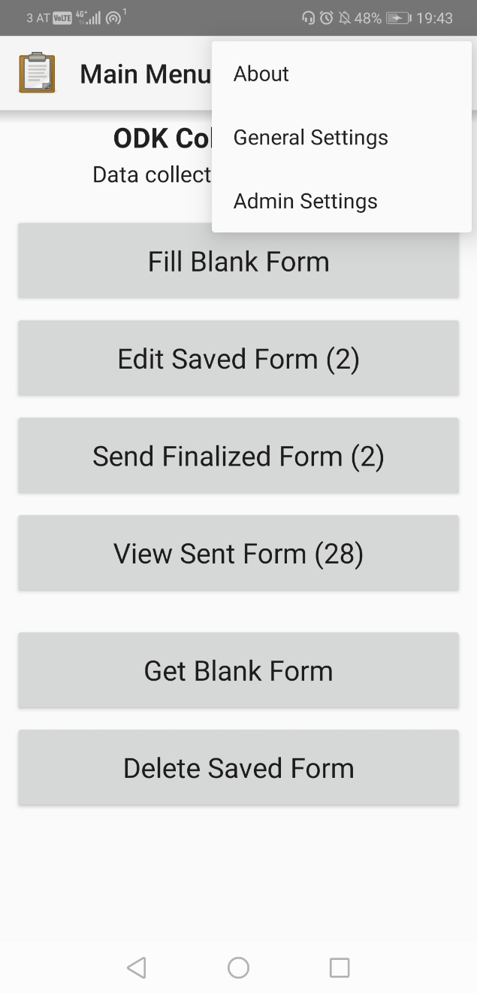 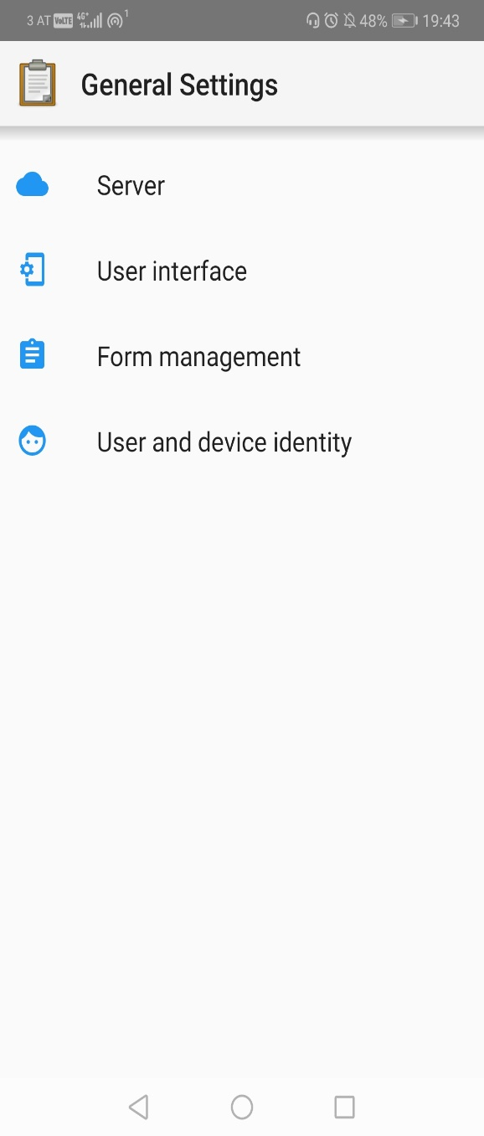

>> Select Server >> configure server settings as follow:

URL: <https://odk.voice-tone.com:8443/odk>

Username: <your username>

Password: <your password>

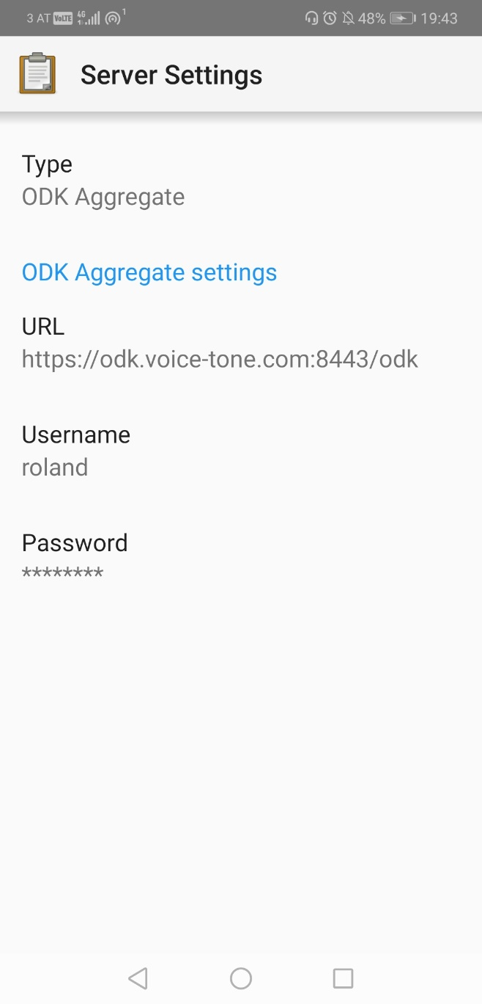

# Get and fill forms on ODK Collect

>> Click on GET BLANK FORMS >> SELECT FORMS >> Click on GET SELECTED

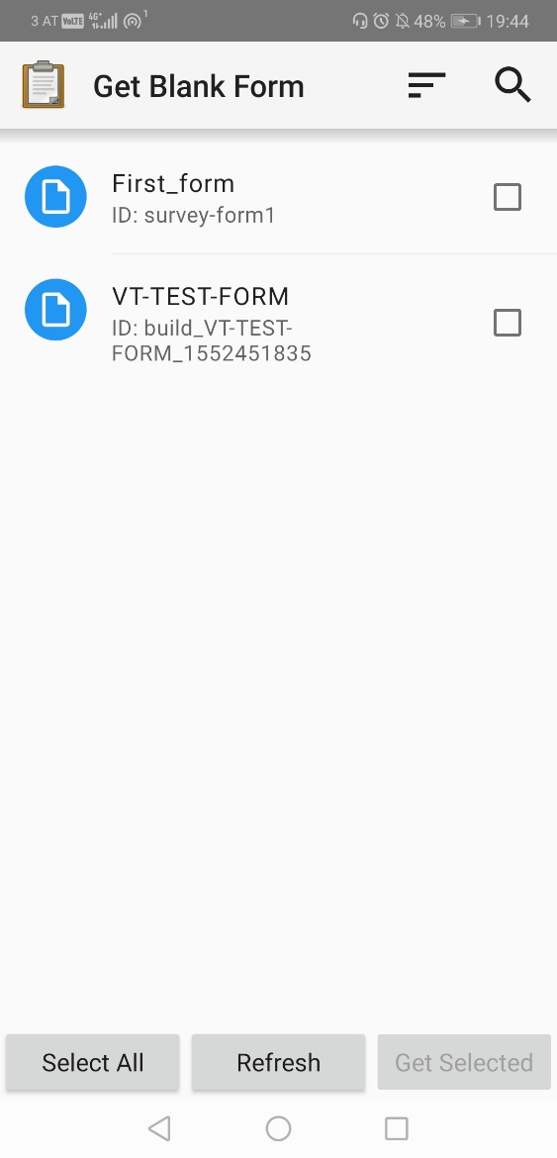 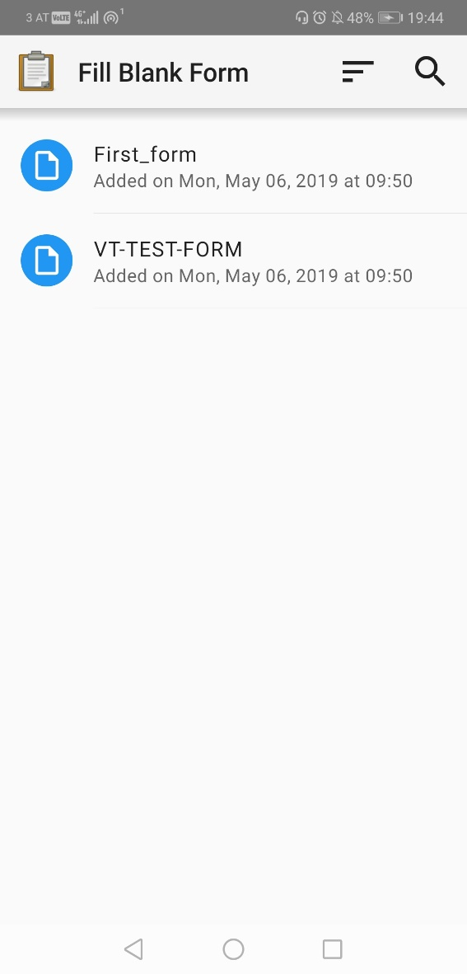

>> Fill a form and submit it

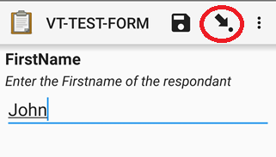

>> Click on the little black arrow in the circle for saving each field.

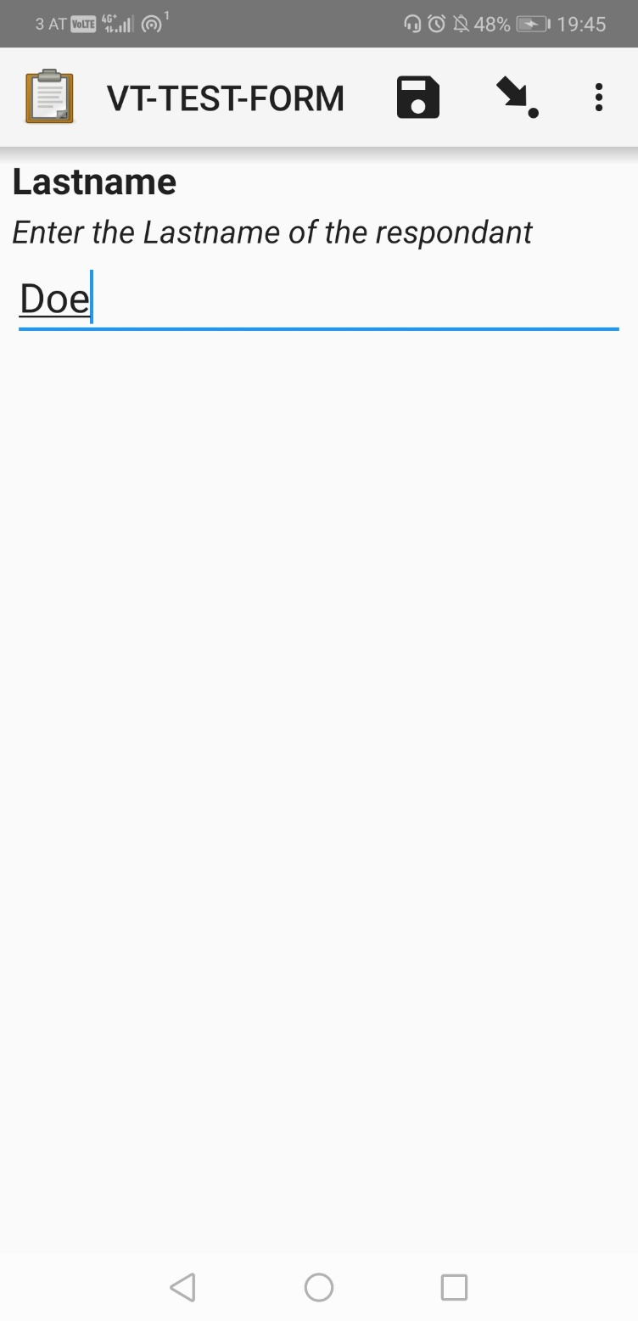

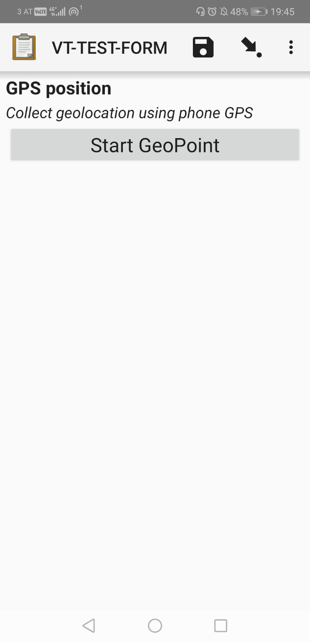

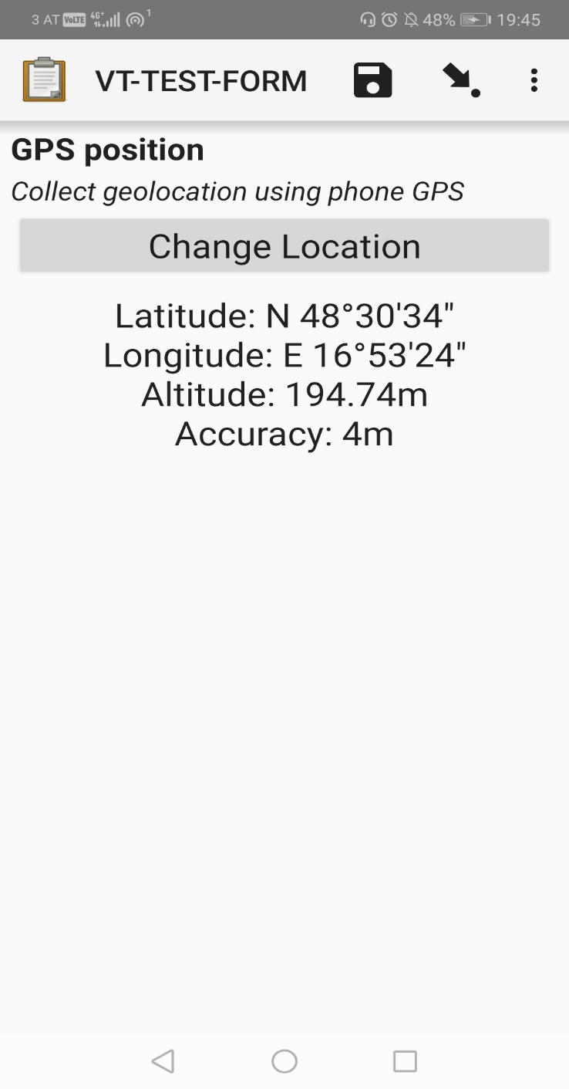

>> After filling the form, click on GO TO END >> then click on SAVE and EXIT.

**Note**: Try to deactivate your internet connection and fill the form several time offline to confirm data is stored locally with server access.

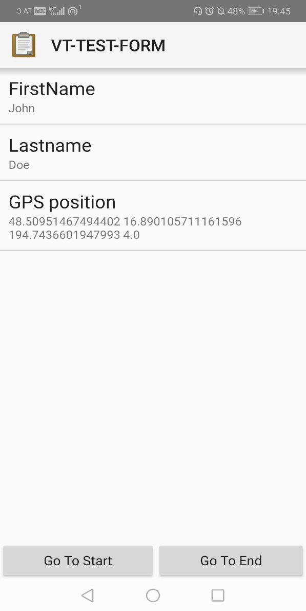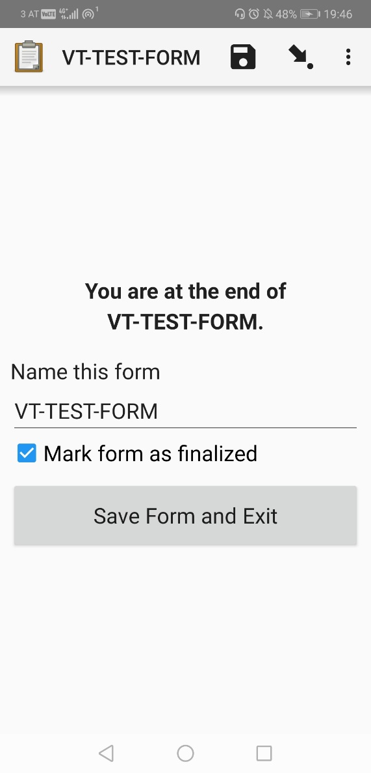

>> go on the SAVED FORM menu to see all the forms filled

**Note**: All forms can be accessed and edited before submission to the server.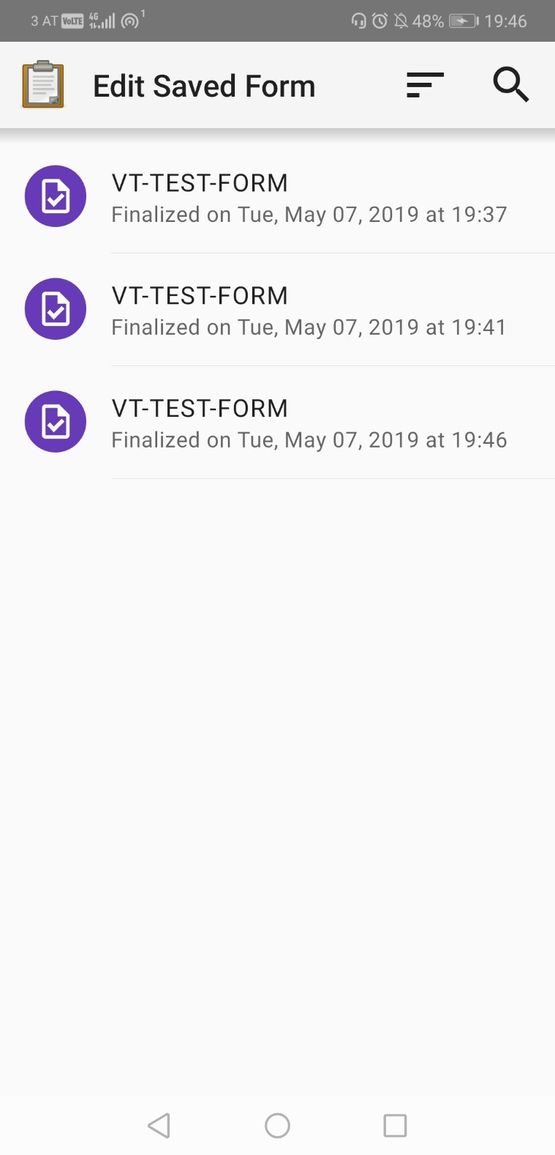

>> Click on SEND FINALISED FORMS >> Select all forms >> Send to server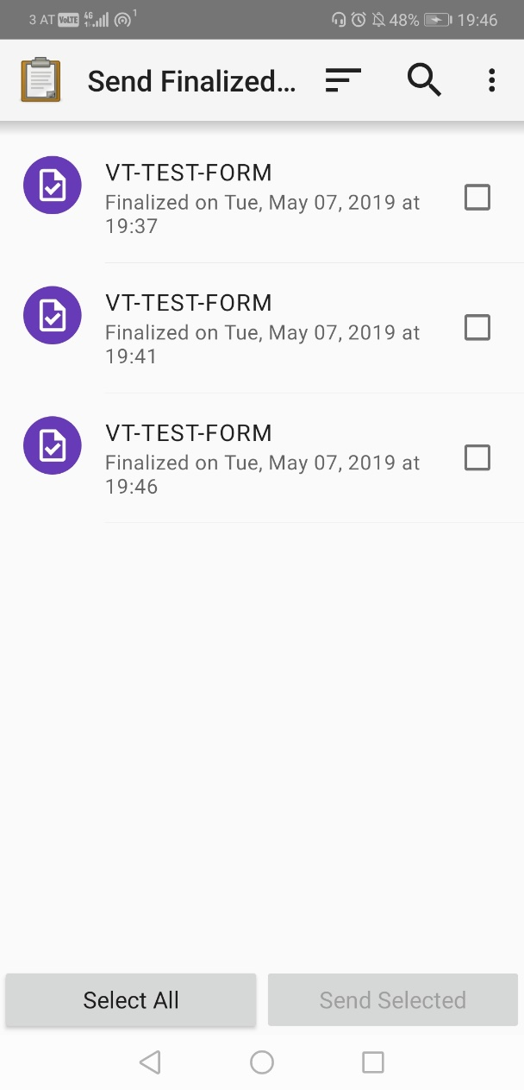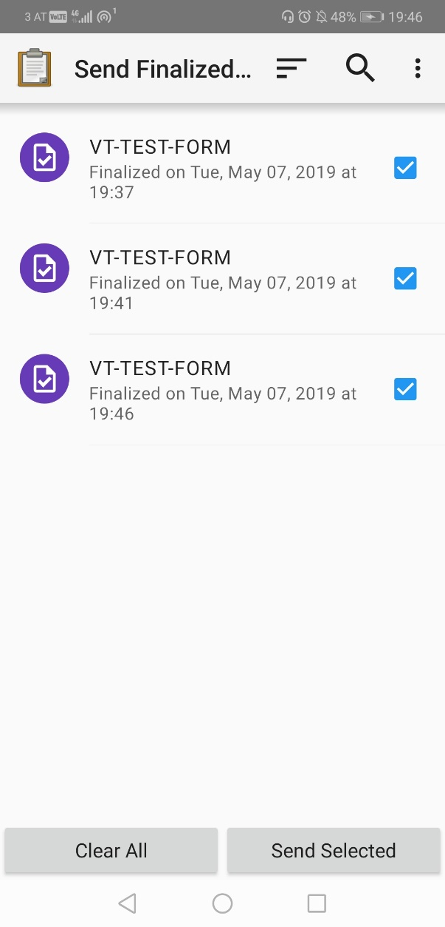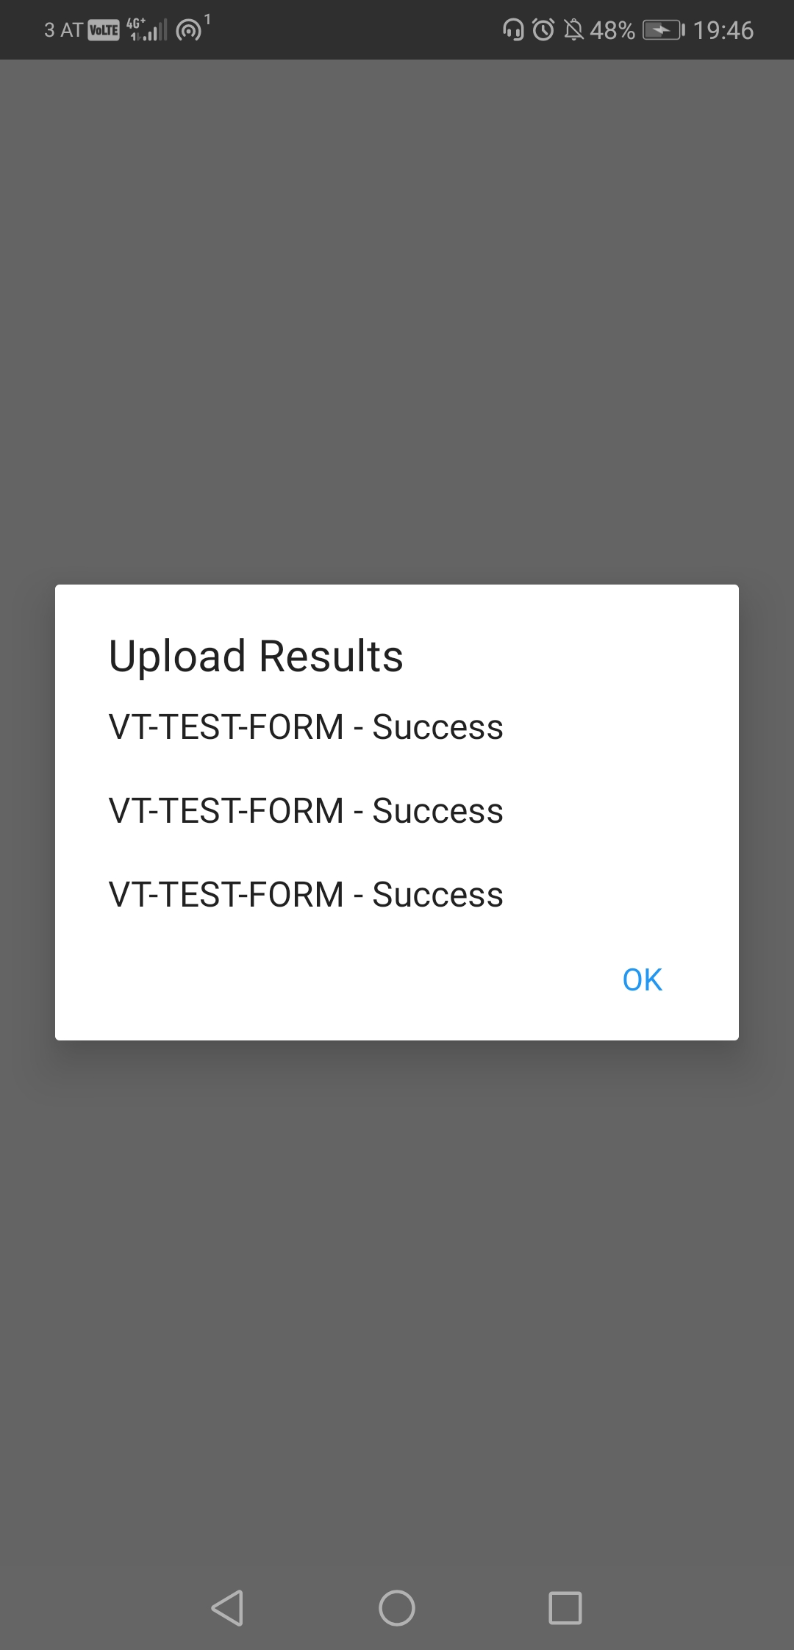

# Basic data visualization on ODK Aggregate

>> Connect to the server to verify the entries uploaded are present by pointing your browser to the following address: <https://odk.voice-tone.com:8443/odk>

>> Login with the username and password provided

>> Select the appropriate form on the top-left corner of the page

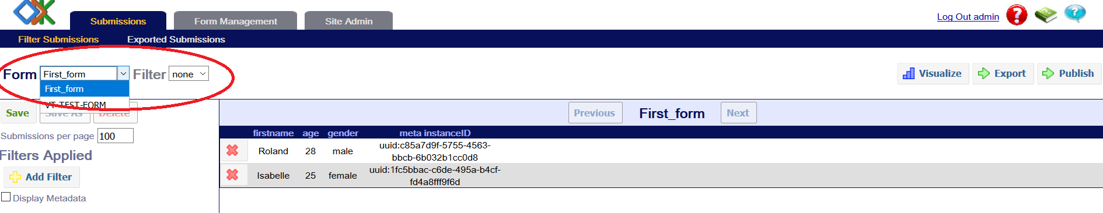

>> View all entries

>> click on visualize on the top right corner of the form

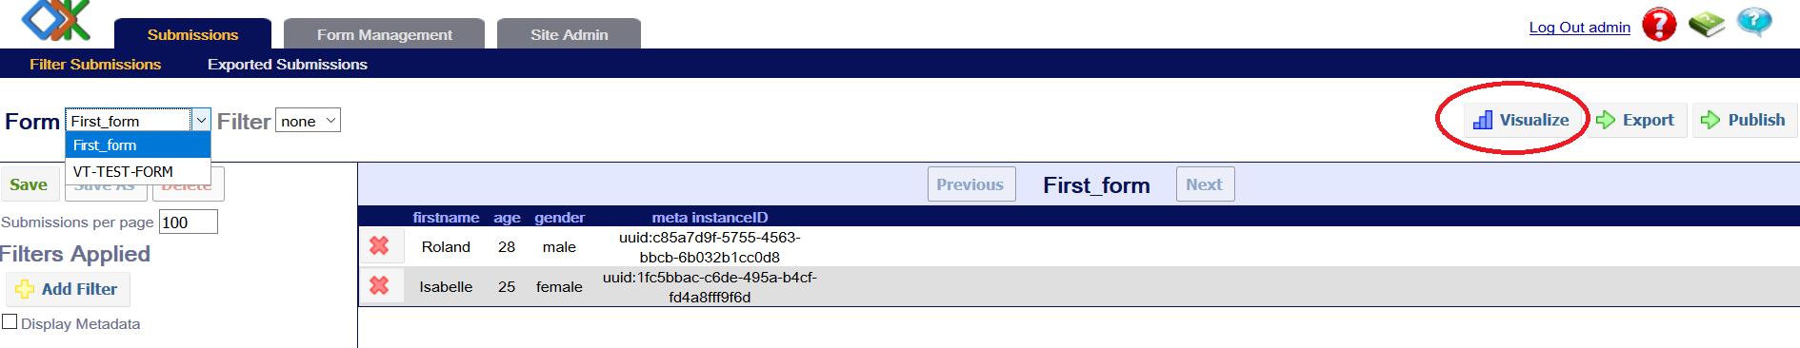

>> Select the type of visualization offered

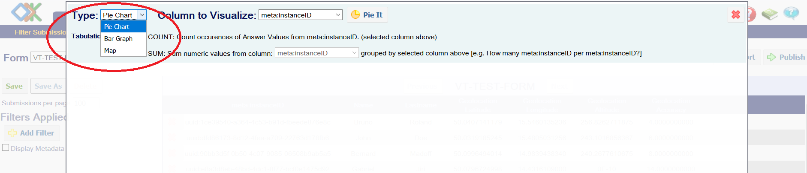

>> Example of map visualization taken on the system (few metro stations in Prague including the CZSO and some train stations on the way back to Vienna were collected as a demo).

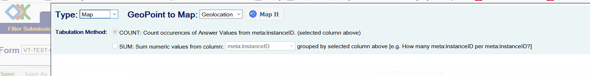

**TRY IT OUT AND SHARE YOUR TOUGHTS ON HOW IT COULD APPLY TO TEST DATA COLLECTIONS VIA MOBILE AT THECZSO.**